### Q1: Write a Java program that reads user input for two integers and perform division. Handle the exception that is thrown when the second number is zero, and display an error message to the user.

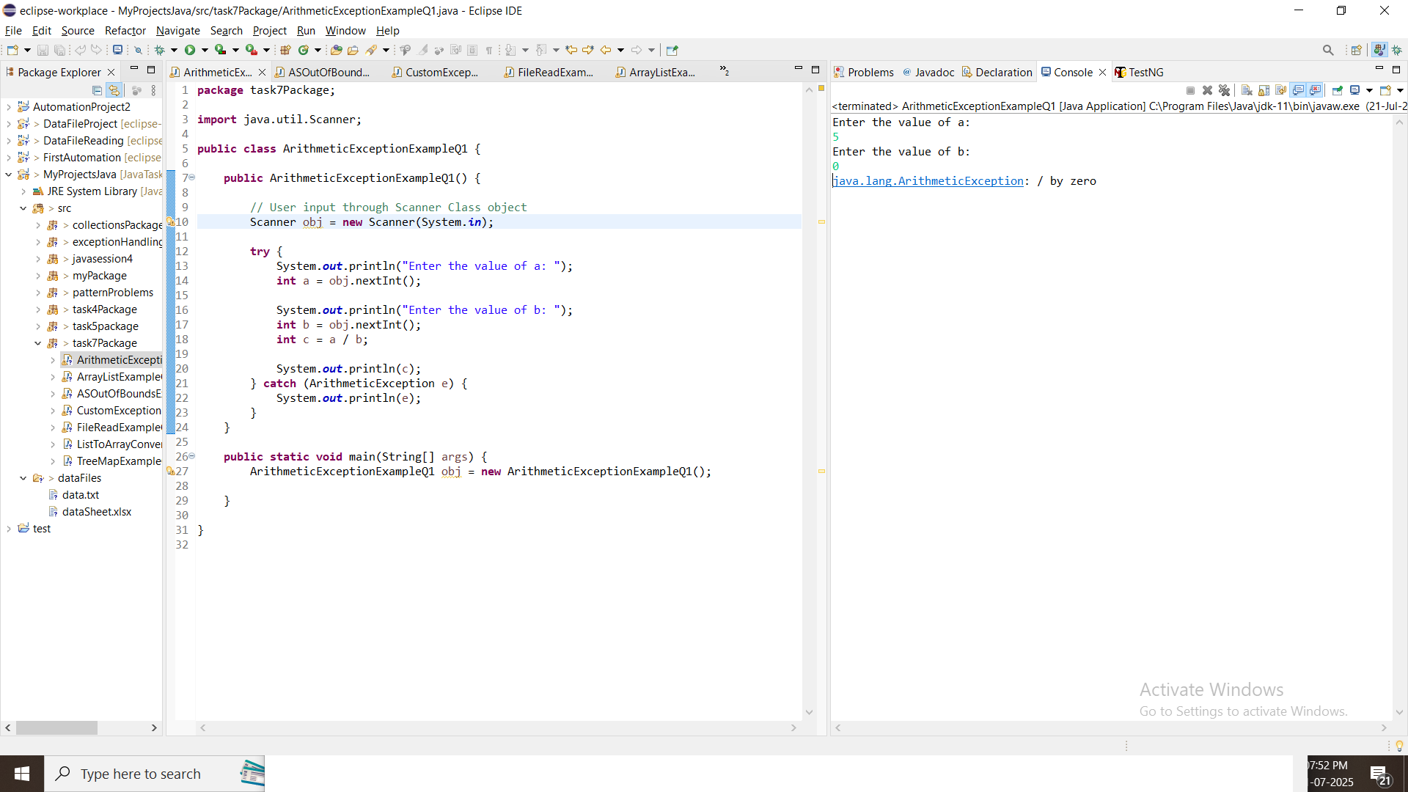

### Q2: Write the code of ArrayIndexOutOfBoundsException & StringIndexOutOfBoundsException?

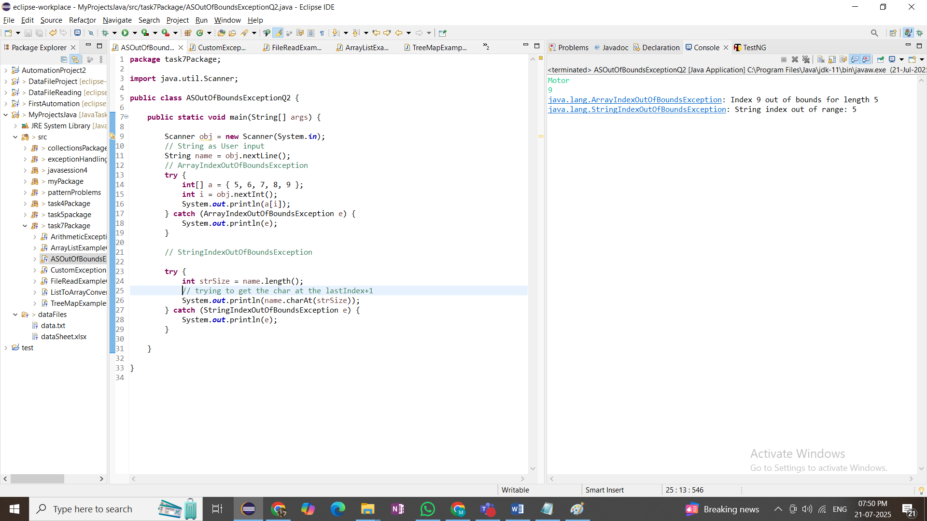

### Q3: Create a custom exception in Java called "InvalidAgeException" that is thrown when the user enters an age less than 18. Implement exception handling in a Java program to catch the "InvalidAgeException" and display an error message.

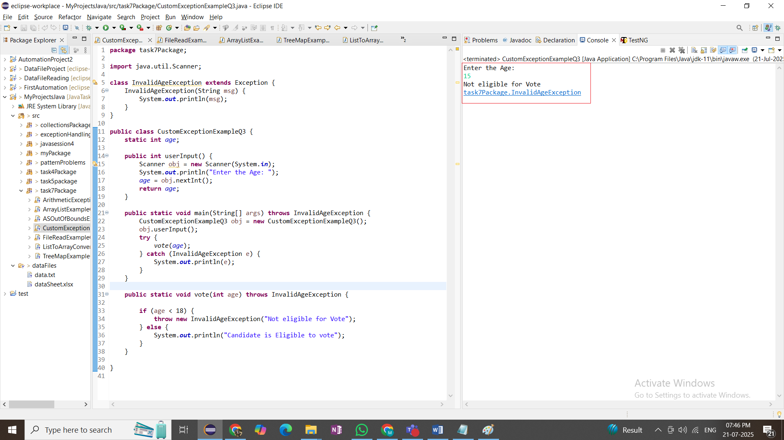

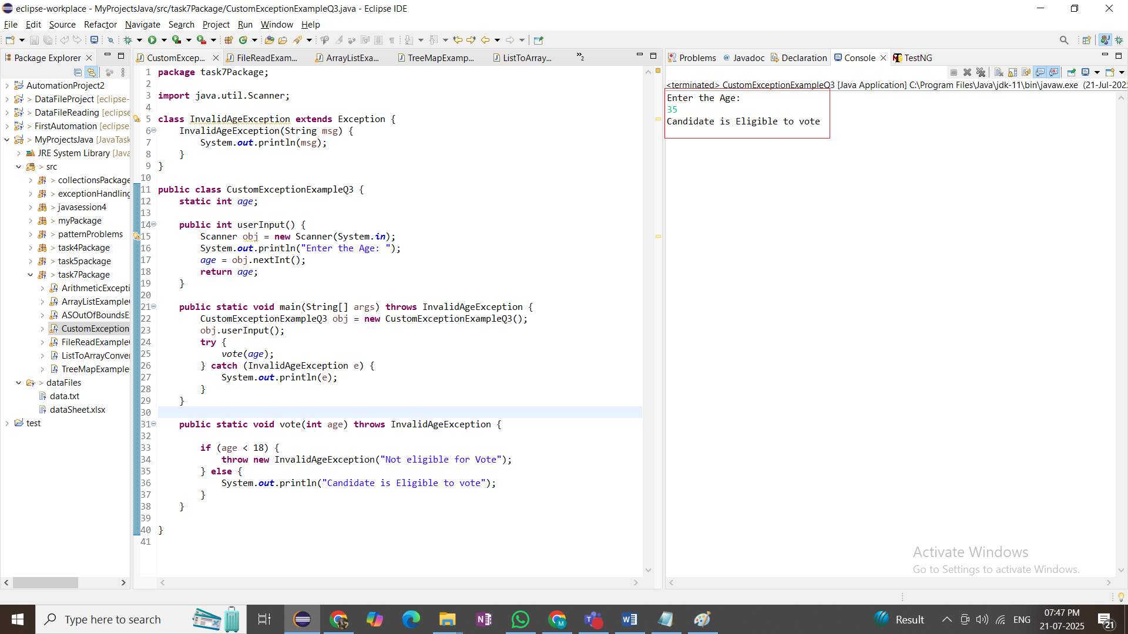

### Q4: Implement exception Handling in a Java program that reads data from a file. If the file does not exist, throw a "FileNotFoundException and display an error message to the user."

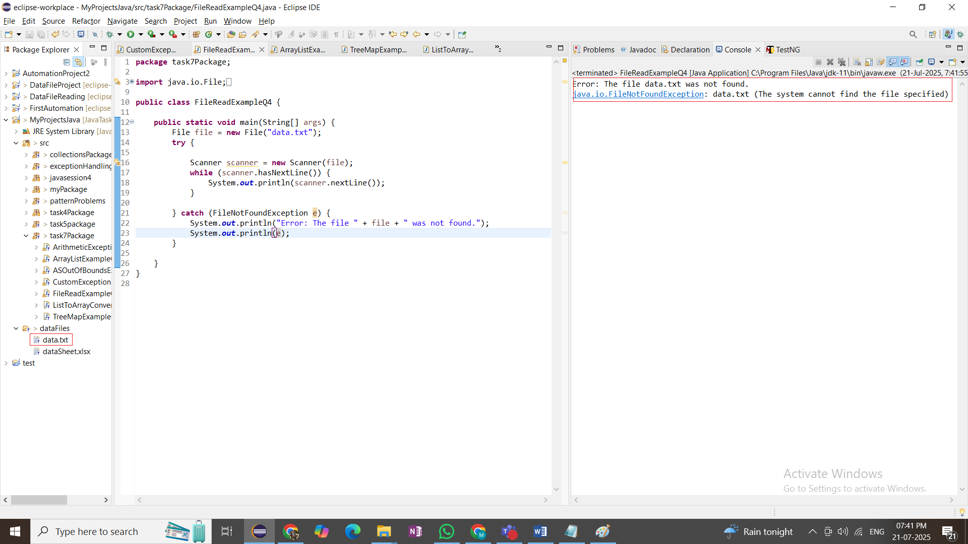

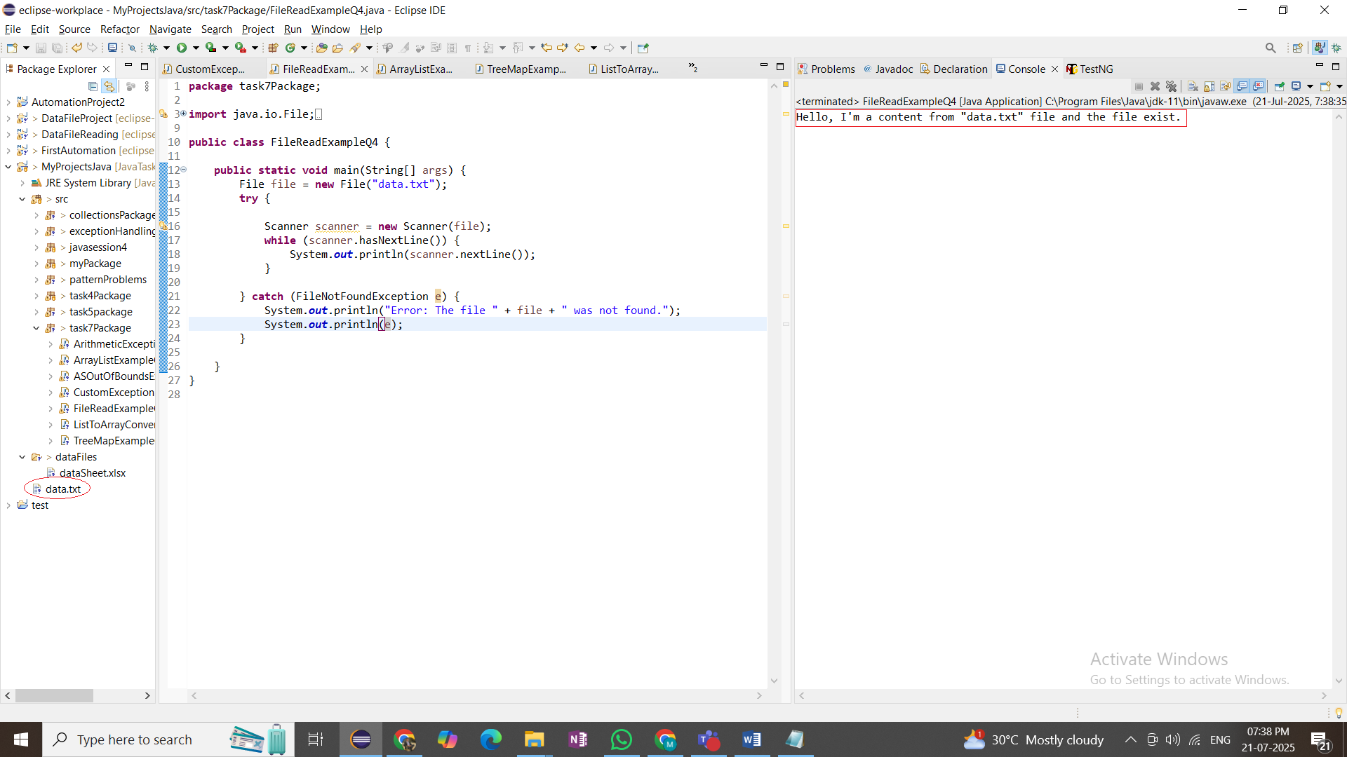

### Q5: Write a Java program to create an ArrayList of Strings and then remove all the elements the ArrayList.

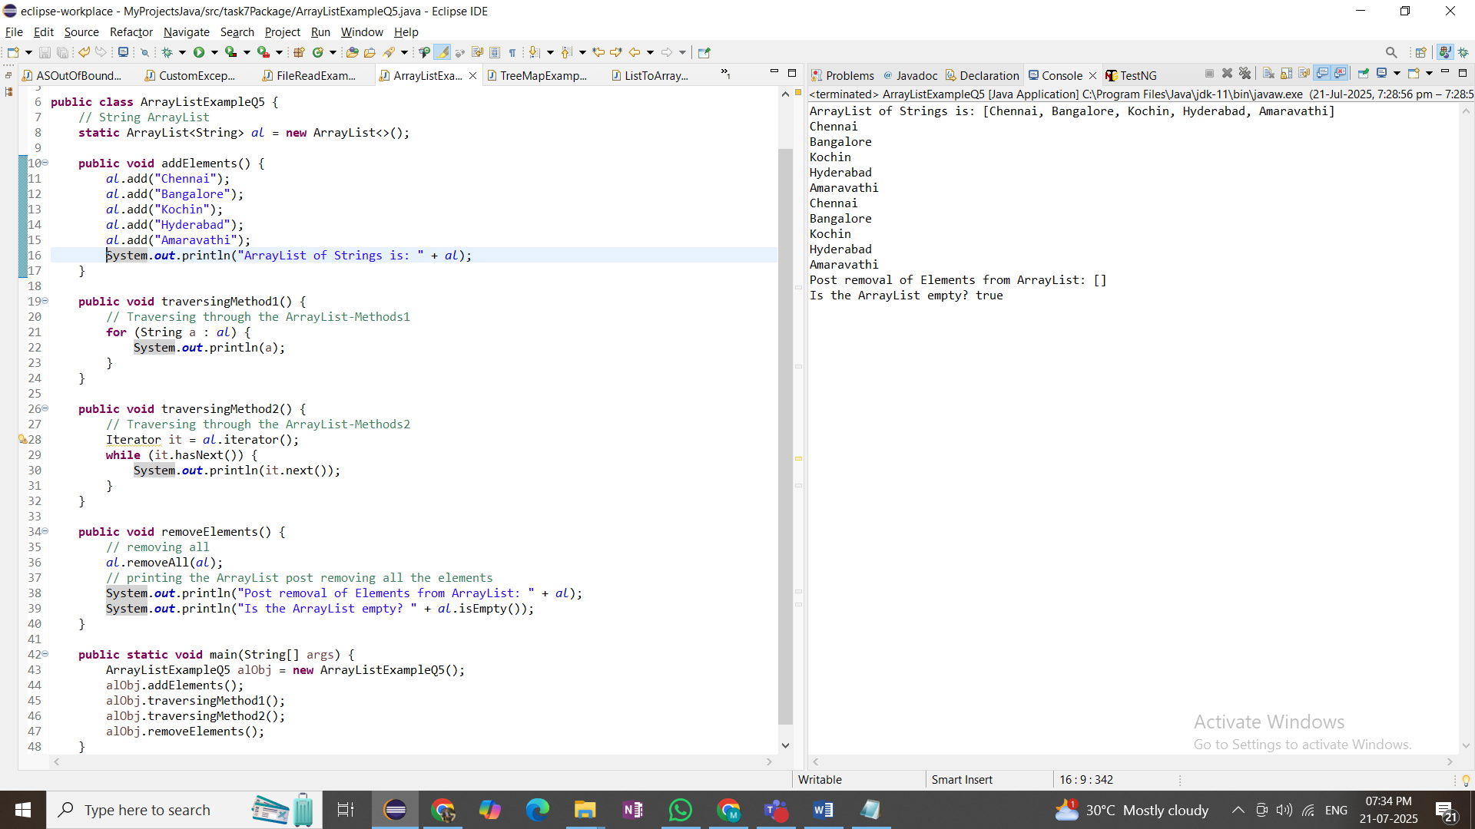

### Q6: Write a Java program to create a TreeMap of employee IDs and Names. then, printout the names of all the employees in alphabetical order.

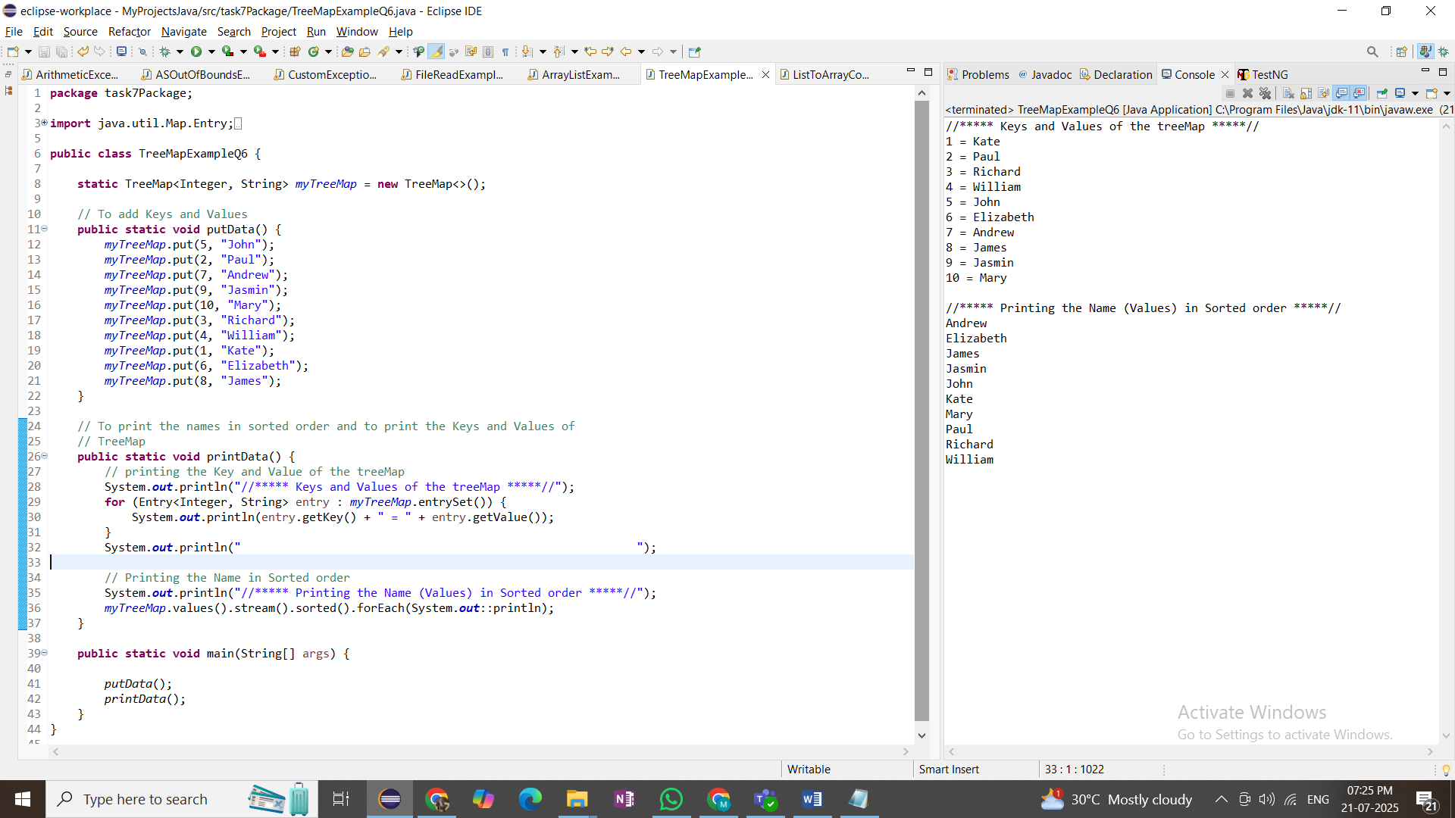

### Q7: Write a program to convert List to Array

